THE OIL SPILL LIABILITY TRUST FUND (OSLTF)

Funding an Oil Spill

The History of the OSLTF

In August 1990, when President George H. W. Bush signed the Oil Pollution Act of 1990 (OPA) into law and authorized use of the Oil Spill Liability Trust Fund (OSLTF or Fund), the Fund was already four years old. Congress created the Fund in 1986, but did not pass legislation to authorize the use of the money or the collection of revenue to maintain it. Only after the 1989 T/V EXXON VALDEZ oil spill and the passage of OPA, was authorization granted. The Coast Guard National Pollution Funds Center (NPFC) manages use of the OSLTF.

Structure, Sources of Revenue, and Uses of the OSLTF

OSLTF Structure - The OSLTF has two major components, the Principal Fund and the Emergency Fund as shown below:

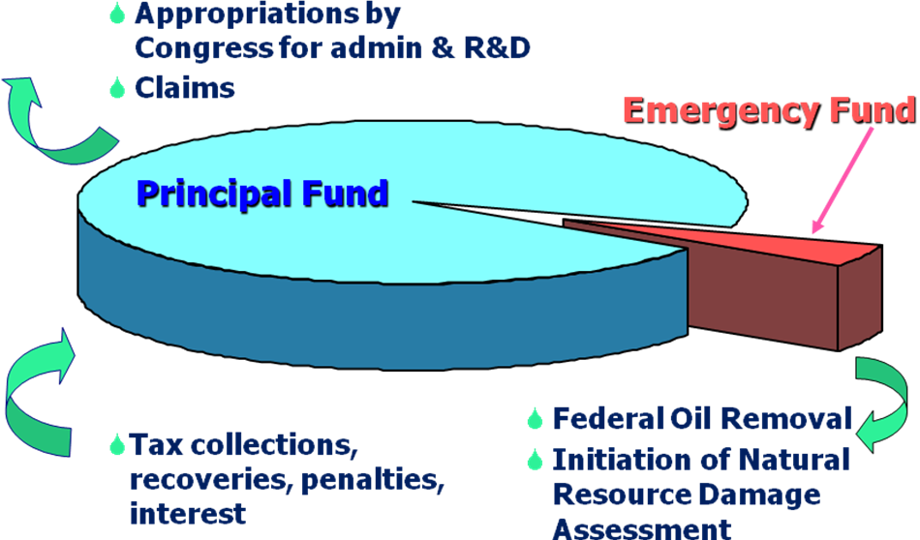

Revenue Sources - The OSLTF has several sources of revenue including:

- Barrel Tax - The largest source of revenue has been a per barrel tax, collected on petroleum produced in, or imported to, the United States. The original 5-cent per barrel tax was suspended in 1994 but was reinstated in 2006 by the Energy Policy Act. Since then, the tax was increased to 8-cents per barrel and will be raised to 9-cents per barrel in 2017 before ending on December 31, 2017.

- Interest - Another recurring source of OSLTF revenue is the interest on the Fund principal from U.S. Treasury investments.

- Cost Recoveries - Responsible Parties (RPs) for oil spills are liable for costs and damages. NPFC bills RPs for costs expended and amounts collected are deposited into the Fund.

- Penalties - In addition to paying for clean-up costs, RPs may incur fines and civil penalties under OPA, the Federal Water Pollution Control Act, the Deepwater Port Act, and the Trans-Alaska Pipeline Authorization Act.

Uses of the Fund - OSLTF uses are delineated by OPA section 1012 and include:

- Removal costs incurred by USCG and EPA FOSCs;
- Payments to Federal, State, and Indian tribe trustees to conduct Natural Resource Damage Assessments (NRDAs) and restorations;
- Payment of claims for uncompensated removal costs and damages;
- Several Federal organizations receive annual appropriations from the OSLTF to cover certain administrative, operational, personnel, enforcement, and R&D costs.

The Emergency Fund is available for Federal On-Scene Coordinators (FOSCs) to respond to oil discharges into the navigable waters, adjoining shorelines, and the Exclusive Economic Zone of the U.S. and to prevent or mitigate the substantial threat of such a discharge. It is also available for Federal natural resource trustees to initiate natural resource damage assessments. To ensure rapid, effective response to oil spills, OPA section 6002 provides that the President has the authority to make available from the OSLTF, without further appropriation, up to $50 million each year for these activities. Funds not used in a fiscal year are carried over to subsequent fiscal years and remain available until expended. To the extent that $50 million is inadequate, authority was granted under the Maritime Transportation Security Act of 2002 to advance up to $100 million from the OSLTF to fund removal activities.

The Principal Fund is used to pay claims and to fund appropriations by Congress to administer the provisions of OPA. OPA provides that any person or government may present a claim for compensation for removal costs or damages resulting from an oil pollution incident covered by the Act. Generally, claims must be presented to the RP before they can be presented to the OSLTF. If the RP does not settle a claim within 90 days, the claimant may sue in court or submit the claim to the NPFC for adjudication. One exception to this is that state governments may submit claims for uncompensated removal costs directly to the NPFC. The types of claims that can be presented include:

- Uncompensated removal costs,
- Natural resource damages,
- Damage to real or personal property,
- Loss of profits and earning capacity,
- Loss of subsistence use of natural resources,
- Loss of government revenues, and
- Increased cost of public services.

Fund Balance - As of December 1, 2015 the OSLTF Emergency Fund balance was $92.7 million. The overall OSLTF balance as of the October 31, 2015, Treasury Trust Fund Financial Report was $4.3 billion.

